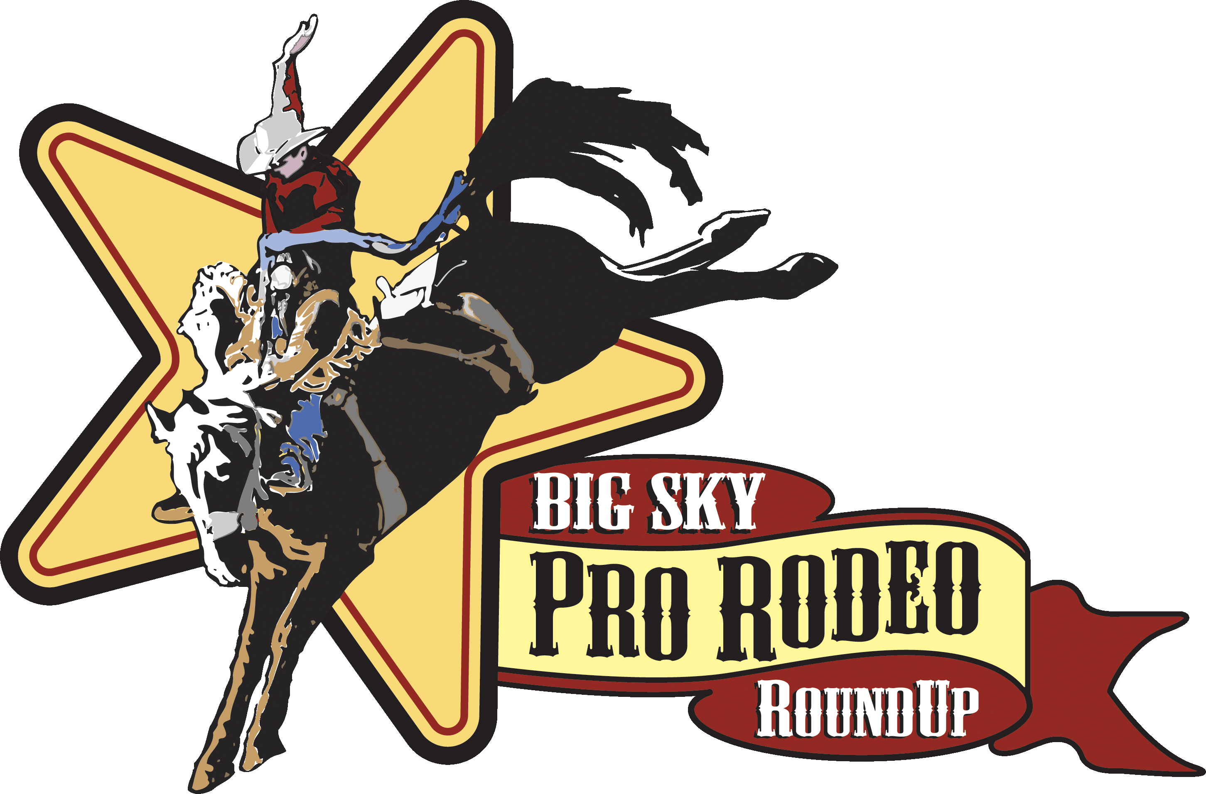
Big Sky Roundup Ranch Rodeo
Sat. Aug. 5th, 2017 – 11:00am
MT Expo Park – Great Falls, MT
Mandatory Team Meeting 10:30AM

Official Entry Form
Ranch/ Team Name: _________________________________________ Entry Fee: $500

Ranch Owner/ Team Captain: ________________________

Is this a true Ranch team: Yes / No

Ranch/ Captain Address: __________________________________ State_____ Zip__________

Ranch/ Captain Phone: _____________________________

Team Members: 4 mandatory (** designates captain) PLEASE PRINT
- You must notify secretary of any team member changes, prior to July 21st.

- **Name _________________________________ Phone #__________________
Address _________________________________________ State_____ Zip__________

____ Release of liability sent with entry. ____ Release of liability will be delivered on day of rodeo.

- Name _________________________________ Phone #____________________

Address _________________________________________ State_____ Zip__________

____ Release of liability sent with entry. ____ Release of liability will be delivered on day of rodeo.

- Name _________________________________ Phone #____________________

Address _________________________________________ State_____ Zip__________

____ Release of liability sent with entry. ____ Release of liability will be delivered on day of rodeo.

- Name _________________________________ Phone #____________________
Address _________________________________________ State_____ Zip__________

____ Release of liability sent with entry. ____ Release of liability will be delivered on day of rodeo.

Bronc Riding
Rider: ________________________________ Alternate: ____________________________
Registration opens June 1, 2017 at 9am. You may call with intent at this time. All entries will be on first come basis. Your entry will be final upon the receipt of your check & official entry form and must be post marked within 7 days of your call or your intent will be voided and another team will be allowed to enter. INTENT TO ENTER – Call Theresa (761-3978)

MAKE CHECKS PAYABLE TO: BIG SKY ROUNDUP COMMITTEE
(REFUNDS due to cancelations will only be granted if rodeo has 10 teams on the day of the event)
MAIL CHECKS TO: Theresa O’Neill, Secretary
3311 Bison Ln.
Great Falls, MT 59404

Top Horse
Nomination Form

- You must notify secretary of any changes.
- NO MORE THAN TWO HORSES PER TEAM CAN BE NOMINATED

Horse: _______________________________ Ranch: ________________________________

Owner: ______________________________ Rider: ________________________________
Age: ______ Sex: ____Stallion ____Mare ____Gelding Color: ________
About the Horse: ____________________________________________________________________________________________________________________________________________________________

Horse: _______________________________ Ranch: ________________________________

Owner: ______________________________ Rider: ________________________________
Age: ______ Sex: ____Stallion ____Mare ____Gelding Color: ________
About the Horse: ______________________________________________________________________________
_____________________________________________________________________________

Release & Waiver
Form

- Re-Print this Form for each contestant.
- Each contestant must have this form filled out and signed before competing or entering the arena!
- Form must be filled out for current year.

Ranch/Team Name: ___________________________ Phone: ______________
Address: __________________________________________________________
Contestant’s Printed Name: __________________________________________
Contestant’s Signature: ____________________________ Date: ____________

RELEASE AND WAIVER
I/We, the undersigned, hereby release the Big Sky ProRodeo Roundup, MT Expo Park Employees, MT Expo Park Advisory Board Members, Cascade County, all Big Sky Roundup Committee members, officers, employees, agents, stock contractors, sponsors or any person helping put on this competition from all claims, demands, action or cause of action, of any kind or nature whatsoever whether now known or ascertained, or which may hereafter develop or accrue me in favor of ourselves, our heirs, representatives, or dependents, on account of, or by reason of, any injury, loss or damage which may be suffered by me or them or any of them to any property, animate or inanimate belonging to me or used by me, because of any matter, thinking or condition of negligence of default whatsoever. I hereby assume and accept the full risk of danger of any hurt, injury or damage which may occur through or be any reason or condition of negligence or any default of any person whatsoever.

