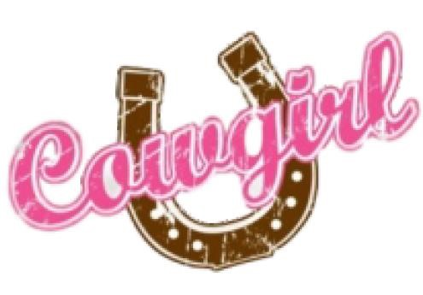
2019 Cowgirl U Friday August 2nd
Montana State Fair Rodeo Grounds Grab your gal pals & learn Rodeo!
Cowgirl U is a rodeo workshop for ladies during the Big Sky Pro Rodeo. You'll spend
time with Rodeo Cowboys learning to Team Rope, Ride the Bull, Barrel Racing/Pole Bending, Bull Fighting/Rodeo Clown and, of course, learn more about Breast Health.
Please print clearly; incomplete forms will not be accepted
Birthdate / / (must be 21 & show ID to attend)
)

(
(S to 2X)
Others in Your Party?
eMail Address
Name & Phone
of Designated Driver
Address
Tee Shirt Size
Name
Phone Number
Registration is from 3:15p to 3:45p on Friday August 2nd
Cowgirl U Rodeo Clinic is from 3:45p to 6:30p
The Rodeo kicks off at 7:00p
Open Registration $25 Cost when you Register Now till the 20th of July
Last Chance $35 Cost when you Register July 21st till the 30th of July
Last Minute Walkups $45 Cost after July 31st till Event time
* Cash, Check or PayPal Accepted * No Refunds Provided * Limited Registrations Available
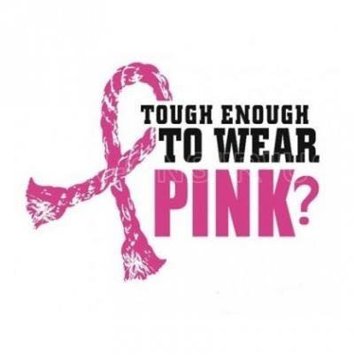
When you register, you will enjoy:
Fun Afternoon with your Gal Pals
Pink Beer & Additional Non-Alcoholic Beverages
Cowgirl U Tee
Light Dinner from Carlson Q
Breast Cancer Awareness & Hope
By signing here, I understand that I am a participant in the Tough Enough To Wear Pink events. I hereby release
Montana ExpoPark and Cascade County MT, its officers, staff, volunteers and sponsors, and Sankey Rodeo Company, Big Sky ProRodeo Roundup Rodeo Committee and Organizers of Cowgirl U from liability for injury, loss or damage associated with participation in this event. I certify I am over the age of 21. I understand the risk of this event, accept all responsibility and agree to participate. I give my permission to use photo(s) of myself in this event for promotional purpose should the occasion arise.
Signature Date

FAQ about Cowgirl U
What is it?
Cowgirl U is a rodeo workshop for ladies during the Big Sky Pro Rodeo Roundup. You’ll get to spend time with rodeo cowboys learning how to rope, ride the buckin’ machine (only if you want) as well as basic information on what the sport of rodeo is and how it’s done. It’s about experiencing a bit of the western way of life.
What do I get for participating?
A really fun afternoon with your girlfriends! Your registration gets you into the rodeo, fairgrounds & special parking. You’ll spend about an hour and a half in the rodeo workshop with the cowboys. Enjoy assorted drinks, snacks and food during the workshop. At 7pm, you're off to the Rodeo to enjoy the New Grandstands! TETWP Seating will be available in the Grandstands.
What do I wear?
Anything that is comfortable for you. We do not recommend flip-flops or skirts, as you are in the dirt, and possibly climbing on the buckin’ machine. You can cowgirl up with boots and jeans, or wear shorts. We don’t care, and neither does anyone else. Being comfortable is the key!
A hat in the sun isn’t a bad idea either.
What do I bring?
An attitude for fun!! Don’t forget your ID as NO ONE UNDER THE AGE OF 21 IS ALLOWED IN THE WORKSHOP AREA! It’ll be warm, so bring items to beat the heat: sunscreen, hat, etc.
How long does the event last?
Registration is 3:15 to 3:45pm. The rodeo clinic is from 3:45 to 6:30. As you rotate through the workshop stations, you can grab refreshments. At 6:45-ish you’ll be seated to enjoy the performance of the Big Sky Pro Rodeo, which starts at 7pm.
Will there be live animals?
Only the cowboys that are helping with the clinic! Just kidding. You’ll be near the holding pens, but you won’t be required to get on any live animals. We’ll have the bull buckin’ machine if you want to give it a try. This clinic is about having fun, learning what rodeo is about, and spending the day with girlfriends raising awareness and money in the battle against breast cancer.
HOW DO I SIGN UP ? ? ? Easy!
- Return this form email to bigskyprorodeo@gmail.com & paypal.me/sarasbellesandsirens
- Drop off the completed form at Maddox Roofing (900 25th St N) with your cash payment - based on the dates of registration (Hours 8:30am to 5pm)

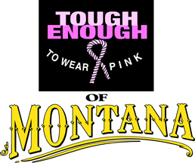
2019 Supporting Sponsors for Cowgirl U
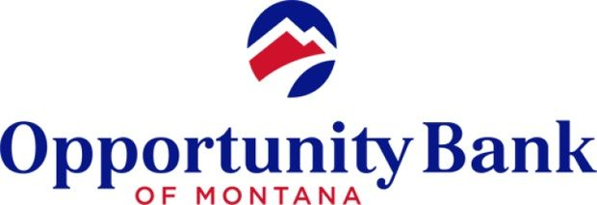
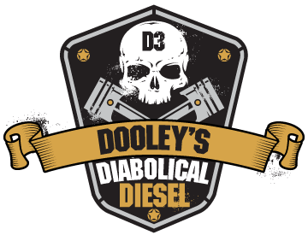
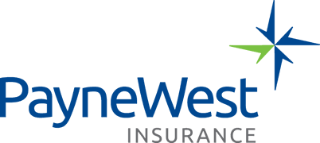
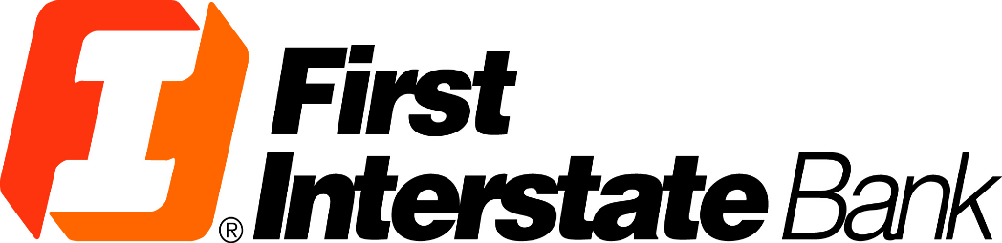
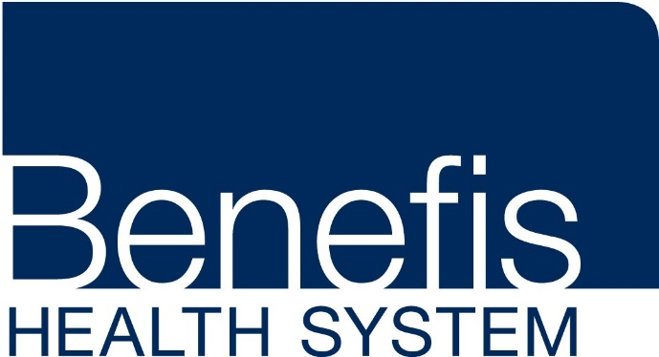

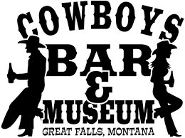
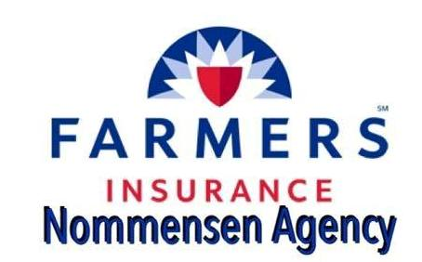

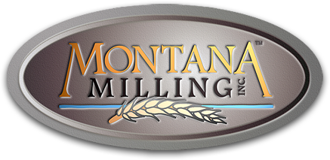
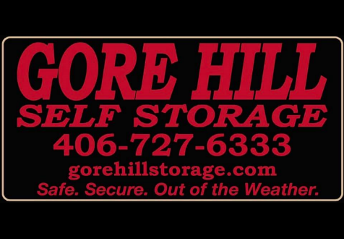
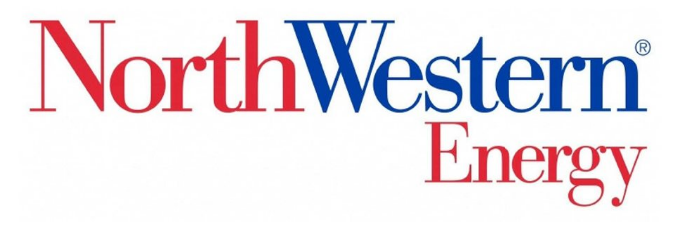

*Gusto Distributing*Carlson Q*Pepsi*Anderson Zurmuehlen*Nobles Westside Liquor*North 40* Allure Aesthetics*Sara’s Belles and Sirens*Physical Therapy of Great Falls*Sports City Cyclery* Parker’s Hangover Tonic*Montana Metal Fabrication*Sletten Construction*Western Livestock*Frontline Ag Solutions*Big Sky Cleaning & Restoration*Serendipity Mobile Boutique*Holmlund Construction & Enterprises*First Bank of Montana*Dahlquist Realtors*American Solutions*

